**EXERCISE-12**

**Question-1:-**

**Output:-**

**Here is the picture without animation of the boat**

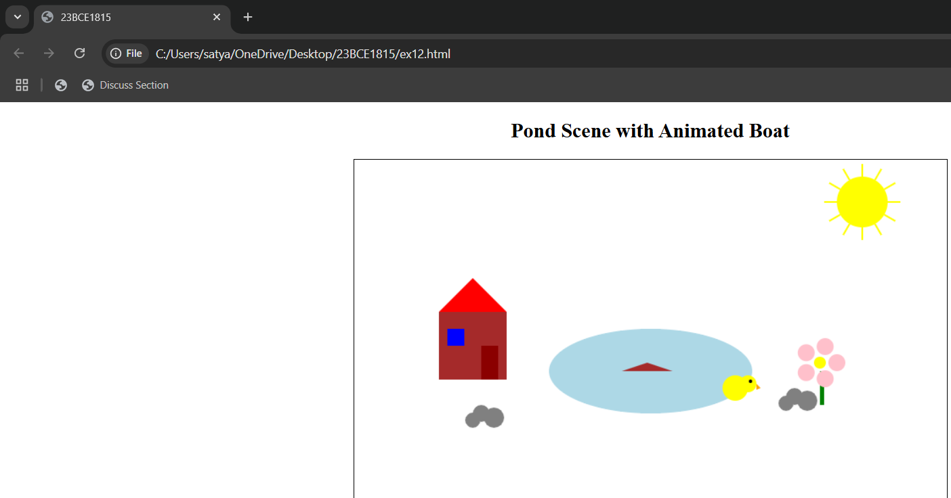

**Question-2:-**

**Output:-**

**Here in the picture the boat will move to right using animation**

**Question-3:-**

**Output:-**

**working analog clock with animation here is one time**

**Here is the another time picture**

**Question-4:-**

**Output:-**

**Using plotly.js bar chat**

**Using plotly.js line chart**

**Using plotly.js pie chart and we can observe the legends also on the right side of the picture**

**Question-5:-**

**Output:-**

**By changing the value of z-index (by increasing box 3) (Green)**

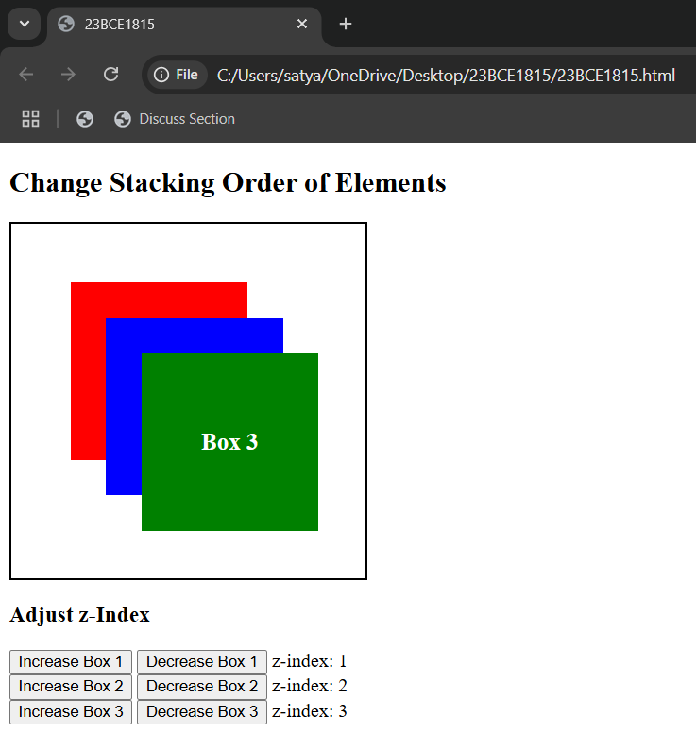

**By changing the value of z-index (by increasing box 2 (Blue)**

**By changing the value of z-index (by increasing box 1(Red)**

